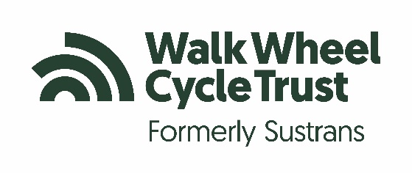
Walk Wheel Cycle Trust press release

Issued:

Contact: Sarah Roe, Senior Media and Communications Officer
Mobile : 07701 273778 E-mail: sarah.roe@walkwheelcycletrust.org.uk

[INSERT SCHOOL] JOINS THE UK’S BIGGEST ACTIVE TRAVEL CHALLENGE
Pupils will take part in Walk Wheel Cycle Trust’s Big Walk and Wheel 2026
Children at [SCHOOL NAME] in [AREA] are planning to walk, wheel, cycle or scoot to school [NEXT WEEK/CHANGE AS APPROPRIATE] as part of the UK’s biggest inter-school active travel challenge.
The Big Walk and Wheel, organised by Walk Wheel Cycle Trust (the new name for Sustrans), will take place from 16- 27 March 2026. It aims to inspire families to make active journeys to boost health, improve air quality and discover how these changes make a difference to the world around them.
[SCHOOL NAME] will [ACTIVITY 1eg Join the whole challenge for the X year running/run a bike breakfast on X].
They also plan to [ACTIVITY 2].
[INSERT TEACHER NAME, JOB TITLE], at [INSERT SCHOOL NAME] said: [INSERT QUOTE]
[INSERT PUPIL NAME] at, said: [INSERT QUOTE]
Now in its 17th year, the annual event, sponsored by Schwalbe Tyres UK limited, will see schools across the UK compete to make the most journeys by walking, wheeling, scooting or cycling to school.
There will be prizes on offer for small and large primary schools, and secondary schools, who log their pupils’ active journeys to school.
Walk Wheel Cycle Trust aims to make it easier for people to walk, wheel and cycle. The Big Walk and Wheel is a great way to form positive habits early in life to help create a more sustainable future.
More people travelling actively for short, everyday journeys - such as to and from school - means less traffic on the roads, easing congestion, reducing pollution and creating safer school neighbourhoods.
Walking, wheeling, cycling or scooting to school also improves the health and wellbeing of students and parents.
Free resources are available to encourage pupils to help reduce air pollution and learn about the benefits of active travel for themselves, their school, their neighbourhood and the whole planet.
Key facts and figures:
- 2,840,575 active travel journeys were completed as part of the Big Walk and Wheel 2025 – this is equivalent to 23 trips to the moon.
- 644,384 pupils participated in 2025 including 93,618 EN/ALN/ASN pupils
- If the children taking active journeys during Big Walk and Wheel had travelled to school by car instead, this could have created just over 2,880 tonnes of CO2 and just over 4,500 kg of NOx.
Can you help us beat last year’s total?
Join in
Comment, share, use the hashtag #BigWalkandWheel
- ENDS -

Notes to the Editor
About us
We’re the charity making it possible for everyone to walk, wheel and cycle.
We work directly with communities to make change happen. Then we evidence the impact to influence policies to push those changes further.
Because people powered movement changes everything. Our health. Our wellbeing. Our world.

Let’s do this! www.walkwheelcycletrust.org.uk
Join the Conversation
Instagram: @WalkWheelCycleTrust
Facebook: @WalkWheelCycleTrust
Bluesky: @WalkWheelCycleT.bsky.social‬

Walk Wheel Cycle Trust is a registered Charity in England and Wales (326550), Scotland (SC039263) and Republic of Ireland (20206824), and a company limited by guarantee registered in England (1797726) at 2 Cathedral Square, Bristol, BS1 5DD.

